1. Agenda:
   1. We configured consumer to handle “Product Created Event” in application.yml.   
      Now the same configuration we will do through Spring Bean.
2. 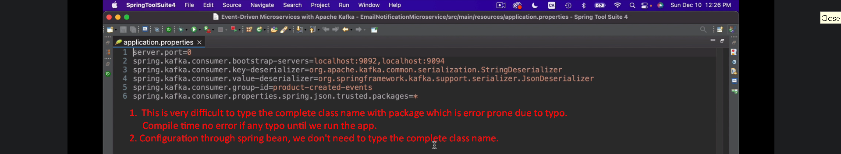
3. 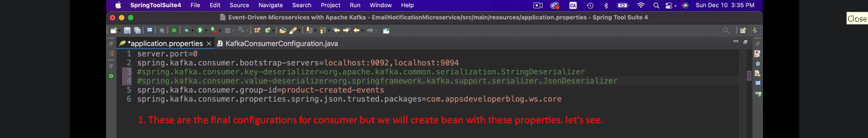

In the following snapshot, correct the package name to this  


1. 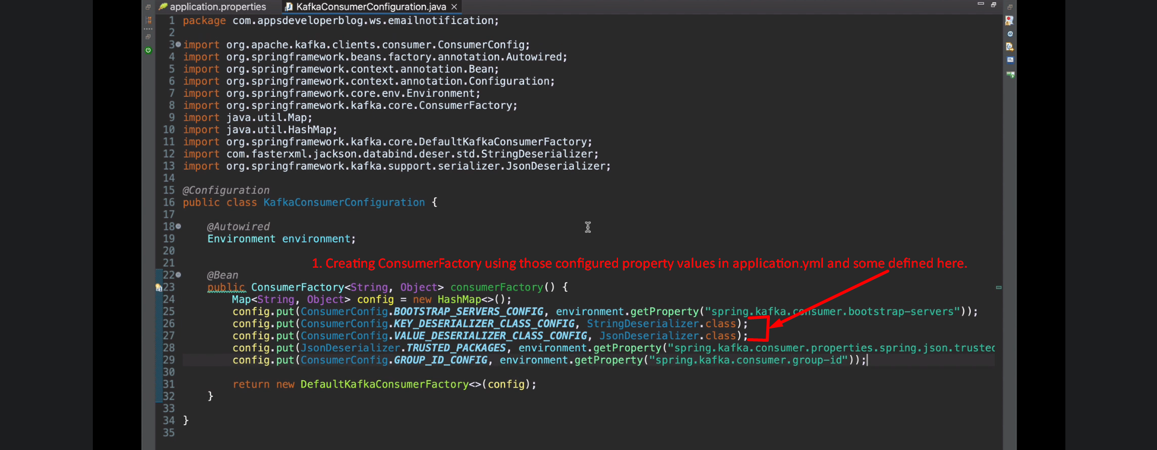  
   ConsumerFactory abstracts the Kafka Consumer Creation centralizing the consumer configuration.